|  |
| --- |
|  |
| Capstone Project Document |

**Bookaholic Social Network**

Report #2 – Screen Design

|  |  |  |
| --- | --- | --- |
| **Bookaholic Social Network** | | |
| **Group Members** |  | SE0 |
|  | SE0 |
|  | SE0 |
|  | SE0 |
|  | SE0 |
| **Supervisor** | Mr. Nguyễn Văn Sang | |
| **Project code** | BSN | |

**- Hanoi, 10/2015 -**

# 1 Introduction

## Purpose

## Definitions, Acronyms and Abbreviations

|  |  |  |
| --- | --- | --- |
| Abbreviations | Description | Comment |
| BSN | Bookaholic Social Network |  |
| Q&A | Question and Answer |  |

**Table 1-1: Definitions, Acronyms and Abbreviations**

## Overview

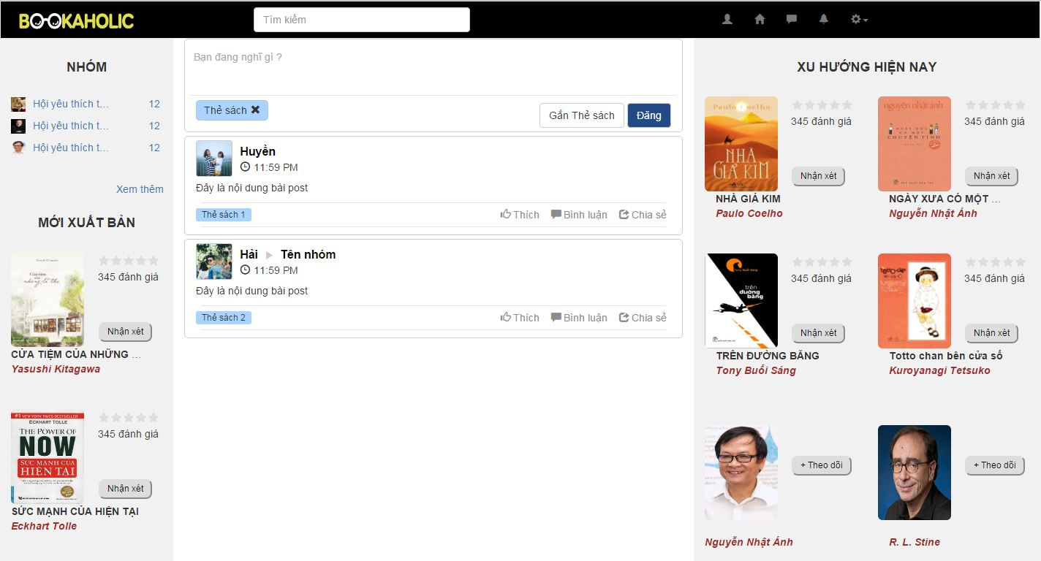

**Figure 1-1: Overview**

# Screen flow

## Register

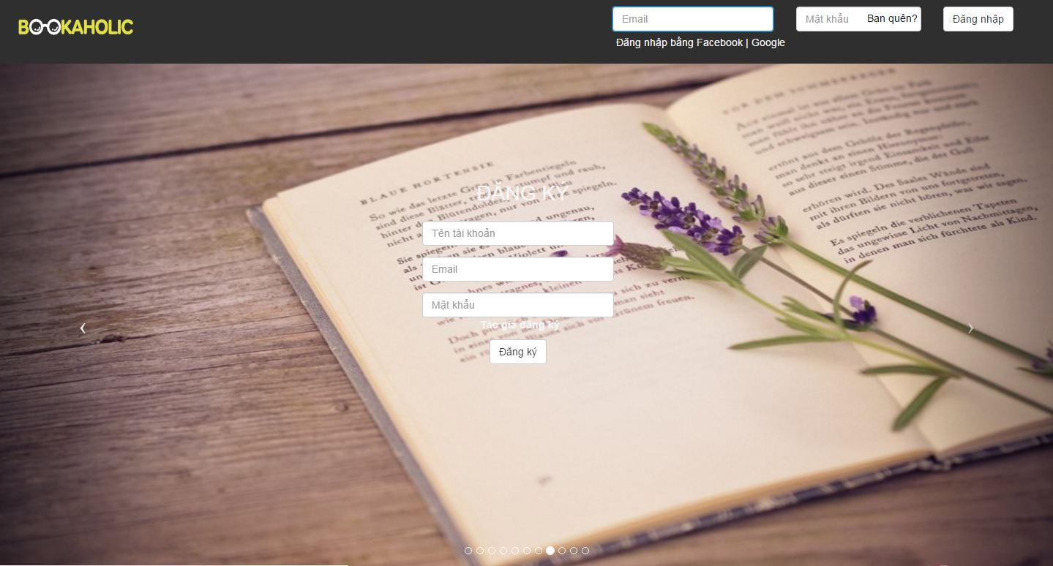

**Figure 2-1: Register screen**

|  |  |  |  |  |  |  |  |
| --- | --- | --- | --- | --- | --- | --- | --- |
| No | Field name | Field name in Vietnamese | Type | Require | Mandatory | Max-Length | Description |
|  | Register | Đăng ký | Label |  | Y |  | Display register form |
|  | Username | Tên tài khoản | Text box | Type | Y | 8-20 | Username of user |
|  | Email | Email | Textbox | Type | Y |  | Email of user |
|  | Password | Mật khẩu | Text box | Type | Y | 8-50 | Password of user |
|  | Sign up | Đăng ký | Button | Click | Y |  | User register a new account |

**Table 2-1: Register screen**

## Login

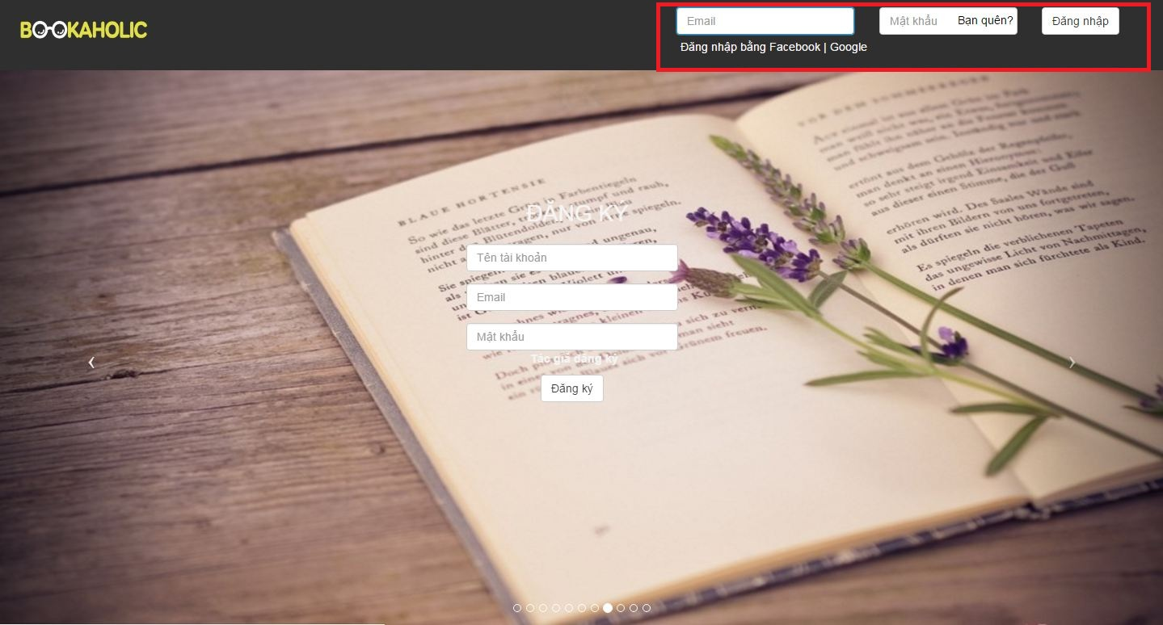

**Figure 2-2: Login screen**

|  |  |  |  |  |  |  |  |
| --- | --- | --- | --- | --- | --- | --- | --- |
| No | Field name | Field name in Vietnamese | Type | Require | Mandatory | Max-Length | Description |
|  | Login with Facebook | Đăng nhập với facebook | Hyperlink | Click | Y |  | Login with facebook |
|  | Login with Google | Đăng nhập bằng Google | Hyperlink | Click | Y |  | Login with google |
|  | Email | Email | Text box | Type | Y |  | Email of registered user |
|  | Password | Mật khẩu | Text box | Type | Y | 8-20 | Password of registered user |
|  | Login | Đăng nhập | Button | Click | Y |  | Login |
|  | Forgot Password | Bạn quên? | Hyperlink | Click | Y |  | Resend password to user |

**Table 2-2: Login screen**

## Homepage



**Figure 2-3: Home Page**

|  |  |  |  |  |  |  |  |
| --- | --- | --- | --- | --- | --- | --- | --- |
| No | Field name | Field name in Vietnamese | Type | Require | Mandatory | Max-Length | Description |
| 1 | Logo | Bookaholic | Image | Click | Y |  | Display homepage |
| 2 | Search box | Ô tìm kiếm | Textbox |  | Y |  | Search author, book. |
| 3 | Icon User | Trang cá nhân | Icon | Click | Y |  | Display userpage |
| 4 | Icon Home | Trang chủ | Icon | Click | Y |  | Reload homepage |
| 5 | Icon comment | Tin nhắn | Icon | Click | Y |  | Displays list of messages |
| 6 | Icon bell | Thông báo | Icon | Click | Y |  | Displays list of notifications |
| 7 | Icon setting | Cài đặt | Icon | Click | Y |  | Display   * Create group * Setting * Logout |
| 8 | Create group | Tạo nhóm | Hyperlink | Click | Y |  | Display group page |
| 9 | Setting | Cài đặt | Hyperlink | Click | Y |  | Display |
| 10 | Logout | Đăng xuất | Hyperlink | Click | Y |  | Redirect to login page |
| 11 | Group | Nhóm | Hyperlink | Click | Y |  | Display group page |
| 12 | See more (group ) | Xem thêm | Hyperlink | Click | Y |  | Show more groups |
| 13 | Book | Sách | Image | Click | Y |  | Show image’s book and name, author.  When click the image’s book then display bookpage. |
| 14 | Rating | Đánh giá | Icon | Click | Y |  | When click the icon star , it will display your reviews of the book.  Show the numbers of rating. |
| 15 | Button comment | Nhận xét | Button | Click | Y |  | Display the form to post comment about this book. |
| 16 | Form comment  (Click button comment ) | Tên sách | Hyperlink | Click | Y |  | Display the new tag : Bookpage |
| Ảnh người dùng | Image |  | Y |  | Display the image of user |
| Khung nhập nội dung | Textarea | Type | Y |  | Allow enter feelings about the book |
| Thẻ sách | Text |  | Y |  | Display book tag |
| Nút post | Button | Click | Y |  | Posted 1 post comments on personal pages |
| 17 | Form comment | Khung nhập nội dung | Textarea | Type | Y |  | Allow enter feelings about the book |
| Gắn thẻ sách | Button | Click | Y |  | Display the input form to enter the booktag |
| Nút post | Button | Click | Y |  | Posted 1 post comments on personal pages |
| 18 | Review form | Ảnh đại diện người dùng | Image |  | Y |  | Display image of user |
| Tên người dùng | Text | Click | Y |  | Display the personal page |
| Thời gian đăng bài | Time |  | Y |  | Show time post comments |
| Nội dung | Text |  | Y |  | Show the comment of user about book |
| Thẻ sách | Text |  | Y |  | Display book tag |
| Thích | Button | Click | Y |  | Switch to liked status and increase the number of likes. |
| Bình luận | Button | Click | Y |  | Displays a list of comments and text area to enter the comments. |
| Chia sẻ | Button | Click | Y |  | Display the share form. |
| 19 | Author | Tác giả | Image | Click | Y |  | Show image’s author and name of author.  When click the image’s book then display author page |
| 20 | Button Follow | Nút theo dõi | Button | Click | Y |  | Switch to followed status |
| 21 | Publisher | Nhà xuất bản | Image |  | Y |  | Show image’s publisher and name of publisher, rating . |

**Table 2-3: Home Page**

## Admin

### Login



**Figure 3-1: Login**

|  |  |  |  |  |  |  |  |
| --- | --- | --- | --- | --- | --- | --- | --- |
| No | Field name | Field name in Vietnamese | Type | Require | Mandatory | Max-Length | Description |
|  | Register | Đăng ký | Label |  | Y |  | Display register form |
|  | Username | Tên tài khoản | Text box | Type | Y | 8-20 | Username of Admin |
|  | Email | Email | Textbox | Type | Y |  | Email of Admin |
|  | Password | Mật khẩu | Text box | Type | Y | 8-50 | Password of Admin |

**Table 3-1: Login**

### Dashboard

## 

**Figure 3-2: Dashboard**

|  |  |  |  |  |  |  |  |
| --- | --- | --- | --- | --- | --- | --- | --- |
| No | Field name | Field name in Vietnamese | Type | Require | Mandatory | Max-Length | Description |
| 1 | Total users | Số người dùng | Label |  | Y |  | Total users registed |
| 2 | Total author | Số tác giả | Label |  | Y |  | Total auhtors registed |
| 3 | Total group | Số tgroup | Label |  | Y |  | Total group registed |
| 4 | Total login of the day | Số lượt truy cập trong ngày | Label |  | Y |  | Total login of the day |
| 5 | New users in the 6 months | Số lượng người dùng mới trong 6 tháng. | Chart |  | Y |  | Total number of new users in 6 months |

**Table 3-2: Dashboard**

* 1. **User management**

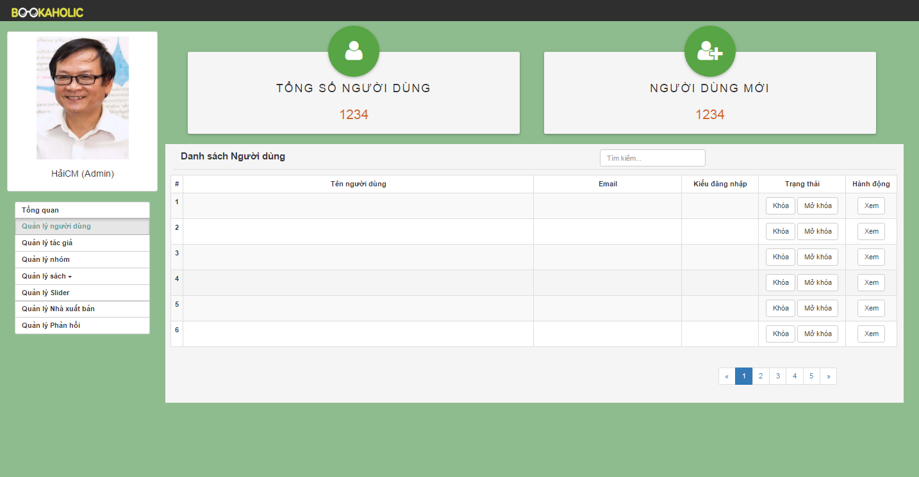

**Figure 3-3: User management**

|  |  |  |  |  |  |  |  |
| --- | --- | --- | --- | --- | --- | --- | --- |
| No | Field name | Field name in Vietnamese | Type | Require | Mandatory | Max-Length | Description |
| 1 | Total users | Tổng số người dùng | Label |  | Y |  | Total users registed |
| 2 | Total new users | Người dùng mới | Label |  | Y |  | Total new users |
| 3 | List user | Danh sách người dùng | Table |  | Y |  | List users  (User name, email, kind of login, status, action) |
| 4 | Lock button | Nút khóa | Butoon | Click | Y |  | Lock user accounts |
| 5 | Unlock button | Nút mở khóa | Button | Click | Y |  | Unlock user accounts |
| 6 | View button | Xem | Button | Click | Y |  | When click the view button then display user page. |

**Table 3-3: User management**

* 1. **Author management**

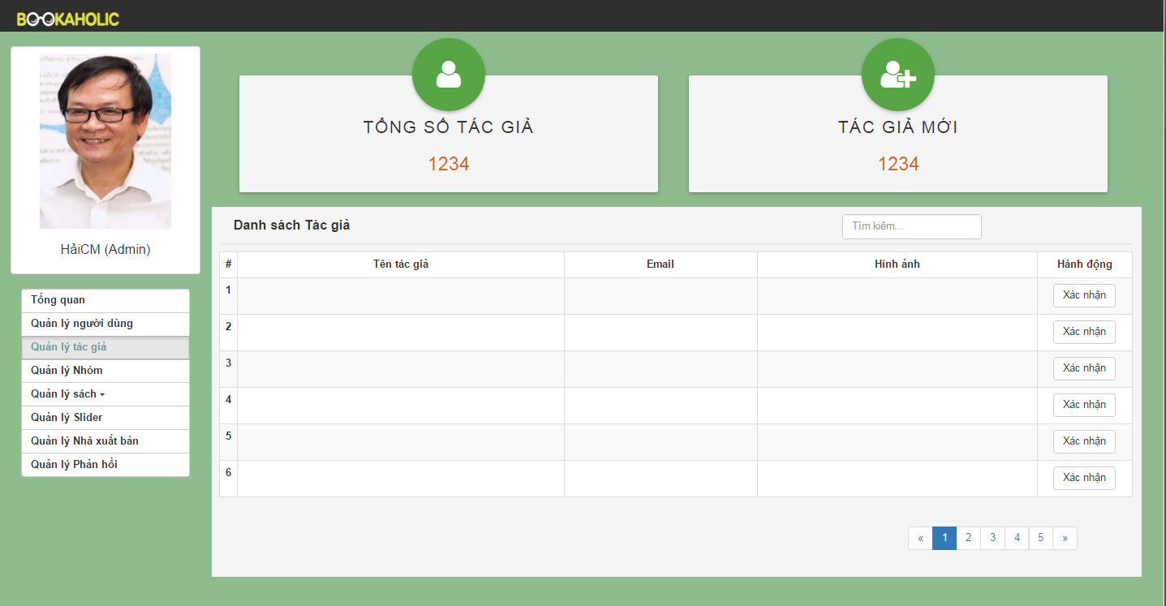

**Figure 3-4: Author management**

|  |  |  |  |  |  |  |  |
| --- | --- | --- | --- | --- | --- | --- | --- |
| No | Field name | Field name in Vietnamese | Type | Require | Mandatory | Max-Length | Description |
| 1 | Total authors | Tổng số tác giả | Label |  | Y |  | Total authors registed |
| 2 | Total new authors | Tác giả mới | Label |  | Y |  | Total new authors |
| 3 | List author | Danh sách tác giả | Table |  | Y |  | List authors  (Author name, email, image, status, action) |
| 4 | Verify  button | Nút xác nhận | Butoon | Click | Y |  | Admin will confirm when author registed |

**Table 3-4: Author management**

* 1. **Group management**

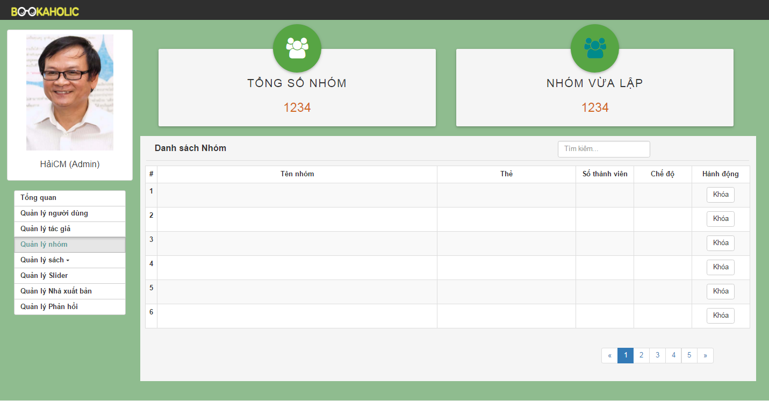

**Figure 3-5: Group management**

|  |  |  |  |  |  |  |  |
| --- | --- | --- | --- | --- | --- | --- | --- |
| No | Field name | Field name in Vietnamese | Type | Require | Mandatory | Max-Length | Description |
| 1 | Total groups | Tổng số nhóm | Label |  | Y |  | Total groups |
| 2 | Total new groups | Tác giả mới | Label |  | Y |  | Total new groups |
| 3 | List group | Danh sách group | Table |  | Y |  | List groups  (Group name, tag book or tag author, number of member, public or private, action) |
| 4 | Lock button | Nút khóa | Butoon | Click | Y |  | Lock group |
|  |  |  |  |  |  |  |  |

**Table 3-5: Group management**

* 1. **Book management**
     1. **Statistics books**

|  |  |  |  |  |  |  |  |
| --- | --- | --- | --- | --- | --- | --- | --- |
| No | Field name | Field name in Vietnamese | Type | Require | Mandatory | Max-Length | Description |
| 1 | Total books | Tổng số sách | Label |  | Y |  | Total books |
| 2 | Button Add book | Thêm sách mới | Button | Click | Y |  | When click the button add book then link to add book page.. |
| 3 | Search | Tìm kiếm | Textbox | Click | Y |  | Search about book |
| 4 | List book | Danh sách sách | Table |  | Y |  | List books (book’name, author, category, publishing date, action) |
| 5 | Edit button | Nút sửa | Button | Click | Y |  | When click button edit then appear popup edit book. |
| 6 | Delete button | Nút xóa | Button | Click | Y |  | When click button delete will this book deleted. |

**Table 3-6-1: Statistics books**

* + 1. **Request add book**

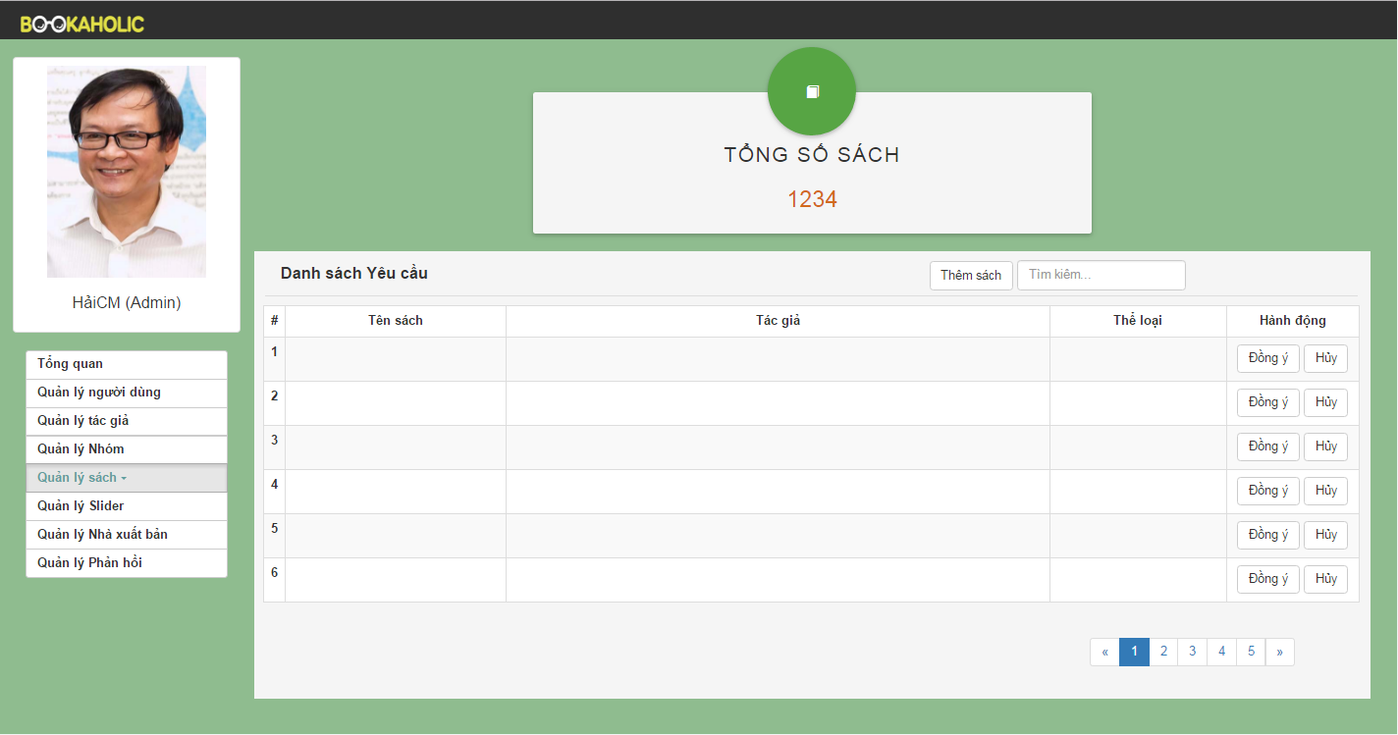

**Figure 3-6-2:Request add book**

|  |  |  |  |  |  |  |  |
| --- | --- | --- | --- | --- | --- | --- | --- |
| No | Field name | Field name in Vietnamese | Type | Require | Mandatory | Max-Length | Description |
| 1 | Total books | Tổng số sách | Label |  | Y |  | Total books |
| 2 | Button Add book | Thêm sách mới | Button | Click | Y |  | When click the button add book then link to add book page… |
| 3 | Search | Tìm kiếm | Textbox | Click | Y |  | Search about book |
| 4 | List book | Danh sách sách | Table |  | Y |  | List books (book’s name, author, category, publishing date, action). |
| 5 | Agree button | Nút đồng ý | Button | Click | Y |  | When click agree button, the new book will be added. |
| 6 | Button Cancel | Nút hủy | Button | Click | Y |  | When click cancel button , the book will be cancel. |

**Table 3-6-2: Statistics books**

* 1. **Slider management**

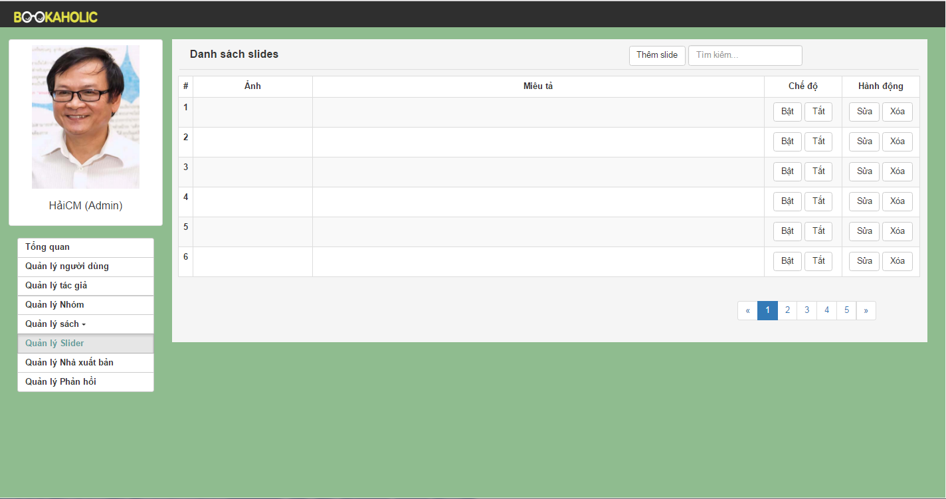

**Figure 3-7-1: Slider management**

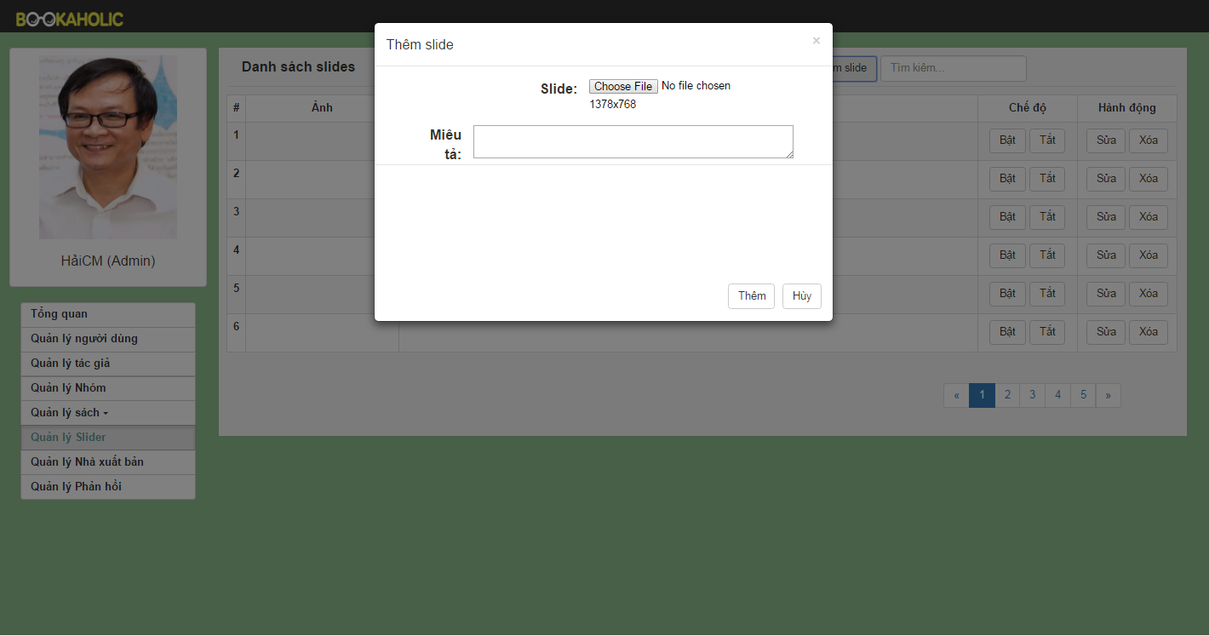

**Figure 3-7-2: Popup add slider**

|  |  |  |  |  |  |  |  |
| --- | --- | --- | --- | --- | --- | --- | --- |
| No | Field name | Field name in Vietnamese | Type | Require | Mandatory | Max-Length | Description |
| 1 | Add slide button | Thêm slide mới | Button |  | Y |  | When click the add slide button the popup will appear . |
| 2 | Search | Tìm kiếm | Textbox | Click | Y |  | Search slide |
| 3 | Popup Add Slide | Khung thêm slide | Model popup |  | Y |  | Popup appear and allow add new slide |
| Chọn file |  |  | Y |  | Allow choose file |
| Miêu tả | Text input |  | Y |  | Enter the description about the slide |
| Nút thêm | Button | Click | Y |  | When choose file and enter description, then click the add button, the slide will be added. |
| Cancel button | Button | Click | Y |  | When click cancel button, add new slide will be canceled. |
| 4 | List slides | Danh sách slide | Table |  | Y |  | List slides (image, description, on button, off button, action). |
| 5 | On button | Nút bật | Button | Click | Y |  | When click on the on button, the slide will be show in the login page. |
| 6 | Off button | Nút tắt | Button | Click | Y |  | When click on the off button, the slide will be don’t show in the login page. |
| 7 | Edit button | Nút sửa | Button | Click | Y |  |  |
| 8 | Delete button | Nút xóa | Button | Click | Y |  | When click on the delete button, the slide will be deleted. |

**Table 3-7: Slider management**

* 1. **Publisher management**

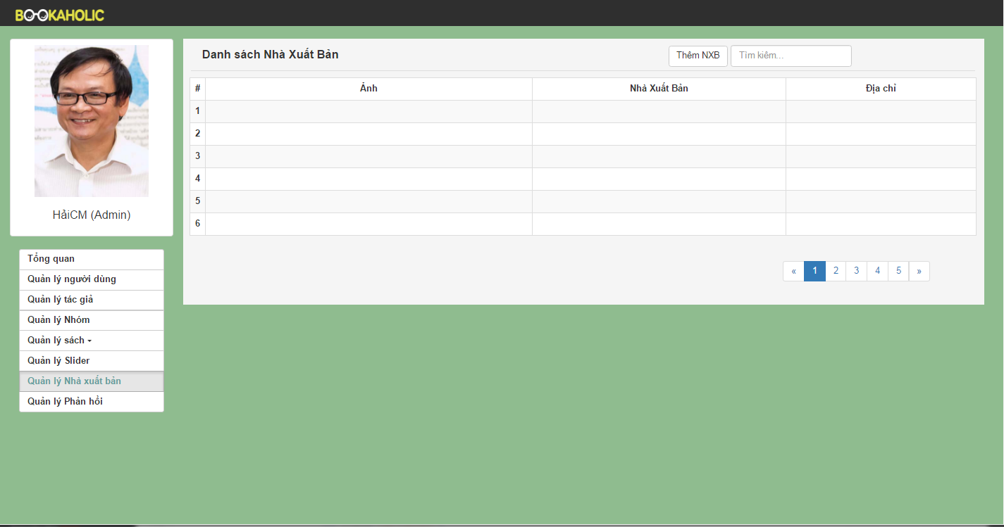

**Figure 3-8: Publisher management**

|  |  |  |  |  |  |  |  |
| --- | --- | --- | --- | --- | --- | --- | --- |
| No | Field name | Field name in Vietnamese | Type | Require | Mandatory | Max-Length | Description |
| 1 | Add publisher button | Thêm nhà xuất bản mới | Button |  | Y |  | When click the add spublisher button the popup will appear . |
| 2 | Popup Add publisher | Khung thêm nhà xuất bản | Model popup |  | Y |  | Popup appear and allow add new publisher . |
| Chọn file |  |  | Y |  | Allow choose file |
| Tên nhà xuất bản | Text input |  | Y |  | Enter the name of publisher |
| Địa chỉ | Text input | Click | Y |  | Enter the address of publisher |
| Nút thêm | Button | Click | Y |  | When choose file and enter name, enter address then click the add button, the publisher will be added. |
| Cancel button | Button | Click | Y |  | When click cancel button, add new publisher will be canceled. |
| 3 | List publishers | Danh sách nhà xuất bản | Table |  | Y |  | List publisher (image, name of publisher, address). |
| 4 | Search | Tìm kiếm | Textbox | Click | Y |  | Search publisher |

**Table 3-8: Publisher management**

* 1. **Report management**
     1. **Report user**

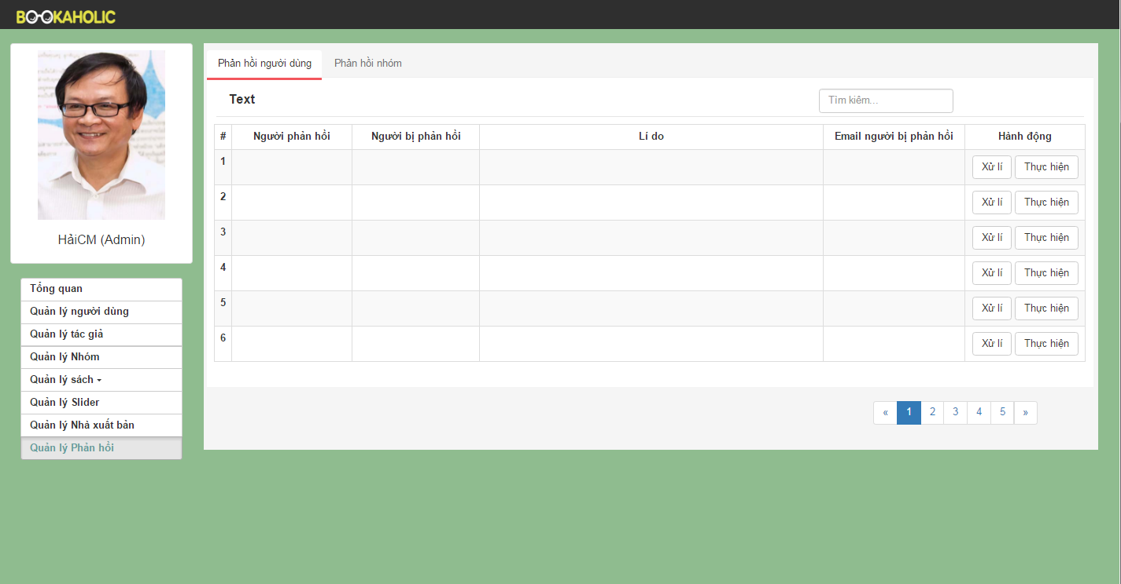

**Figure 3-9-1: Report user**

|  |  |  |  |  |  |  |  |
| --- | --- | --- | --- | --- | --- | --- | --- |
| No | Field name | Field name in Vietnamese | Type | Require | Mandatory | Max-Length | Description |
| 1 | Search | Tìm kiếm | Textbox | Click | Y |  | Search user |
| 2 | List users | Danh sách người dùng | Table |  | Y |  | List users (reporter, reported, email of reported, action ). |
| 3 | Handling button | Nút xử lý | Button | Click | Y |  |  |
| 4 | Execute button | Nút thực hiện | Button | Click | Y |  |  |

**Table 3-9-1: Report user**

* + 1. **Report group**

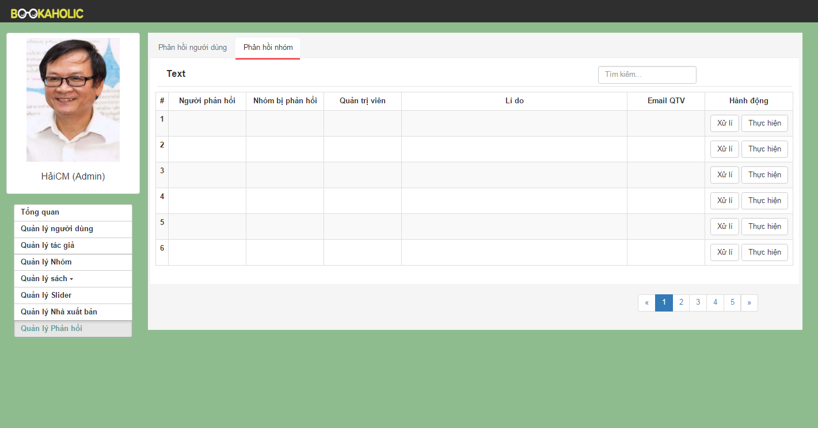

**Figure 3-9-2: Report group**

|  |  |  |  |  |  |  |  |
| --- | --- | --- | --- | --- | --- | --- | --- |
| No | Field name | Field name in Vietnamese | Type | Require | Mandatory | Max-Length | Description |
| 1 | Search | Tìm kiếm | Textbox | Click | Y |  | Search user |
| 2 | List groups | Danh sách nhóm | Table |  | Y |  | List groups (reporter, group was reported, reason,administrators, email of adminstrators action ). |
| 3 | Handling button | Nút xử lý | Button | Click | Y |  |  |
| 4 | Execute button | Nút thực hiện | Button | Click | Y |  |  |

**Table 3-9-2: Report group**